**Web Programming**

Lab - 15

React JSX

Name: Sushen Grover

Reg No: 23BCE1728

Slot: L11+L12+L31+L32

Class No: CH2024250502774

Course Code: BCSE203E

Faculty: Dr. L.M. Jenila Livingston

Question 1:

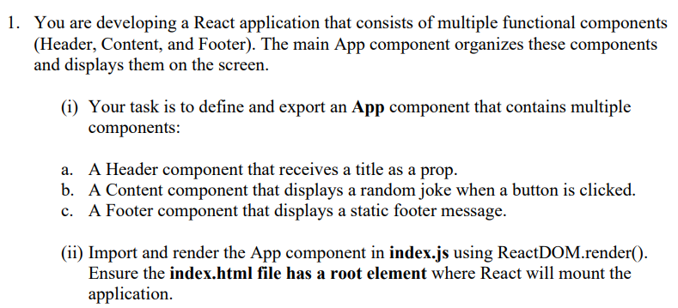

Code:

**App.jsx**

import Header from './components/header.jsx'

import Footer from './components/footer.jsx'

import Content from './components/content.jsx'

import { useState } from 'react'

import reactLogo from './assets/react.svg'

import viteLogo from '/vite.svg'

// import './App.css'

function App() {

  const jokes=[

    "I told my suitcase that there will be no vacations this year… now it's full of emotional baggage.",

    "Parallel lines have so much in common—it's a shame they'll never meet.",

    "I used to play piano by ear, but now I use my hands.",

    "I asked the librarian if the library had any books on paranoia… she whispered, They're right behind you.",

    "I told my wife she should embrace her mistakes… she gave me a hug.",

    "My friend said he didn't understand cloning—I told him, That makes two of us.",

    "I started a band called 999 Megabytes… we still haven't got a gig.",

    "I tried to catch fog yesterday… but I mist.",

    "I told my dog I needed some space… now he won't stop barking at the stars.",

    "Why did the scarecrow win an award? Because he was outstanding in his field!"

  ];

  function fetchJoke(){

    let ind=Math.floor(Math.random()*9);

    return jokes[ind]

  }

  return (

    <>

      <Header titleName="This is a prop title"></Header>

      <Content getJoke={fetchJoke}></Content>

      <Footer></Footer>

    </>

  )

}

export default App

**Header.jsx**

import React from 'react'

const Header = (props) => {

  return (

    <div>

        <h2>{props.titleName}</h2>

    </div>

  )

}

export default Header

**Content.jsx**

import React from 'react'

const Content = (props) => {

  return (

    <div>

        <p>{props.getJoke()}</p>

    </div>

  )

}

export default Content

**Footer.jsx**

import React from 'react'

const Footer = () => {

  return (

    <div>This is a footer Component</div>

  )

}

export default Footer

Output:





Question 2,3,4:

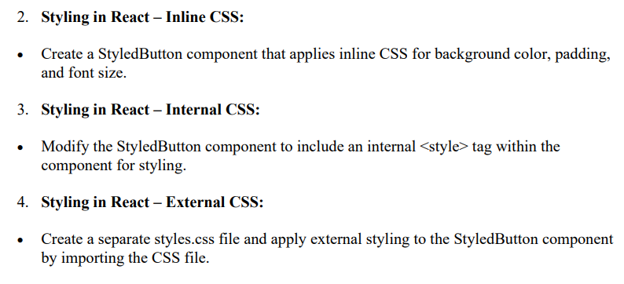

Code:

**App.jsx**

import { useState } from 'react'

import reactLogo from './assets/react.svg'

import viteLogo from '/vite.svg'

// import './App.css'

import StyledButton1 from './Components/StyledButton1'

import StyledButton2 from './Components/StyledButton2'

import StyledButton3 from './Components/StyledButton3'

function App() {

  const style1=`

  p{

  background-color:grey;

  font-size:5px;

  }

  `

  return(

    <>

    <p>Q2 Inline CSS</p>

    <StyledButton1></StyledButton1>

    <p>Q2 Internal CSS</p>

    <StyledButton2></StyledButton2>

    <p>Q3 External CSS</p>

    <StyledButton3></StyledButton3>

    </>

  )

}

export default App

**styledButton1.jsx**

import React from 'react'

const StyledButton1 = () => {

  return (

    <div>

        <button style={{backgroundColor:"yellow",padding:5,fontSize:10}}>Button1</button>

    </div>

  )

}

export default StyledButton1

**styledButton2.jsx**

import React from 'react'

const StyledButton2 = () => {

  const style1=`

  button{

  background-color:skyblue;

  padding:5px;

  font-size:10px;

  }

  `;

    return (

    <div>

        <style>{style1}</style>

        <button>Button2</button>

    </div>

  )

}

export default StyledButton2

**styledButton3.jsx**

import React from 'react'

import './StyledButton3.css'

const StyledButton3 = () => {

  return (

    <div>

        <button className='styledButton'>Button3</button>

    </div>

  )

}

export default StyledButton3

**styledButton3.css**

.styledButton{

    background-color: aquamarine;

    padding: 5px;

    font-size: 10px;

}

Output:

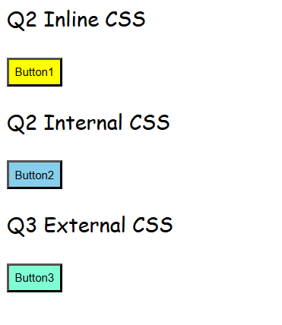

Question 5:

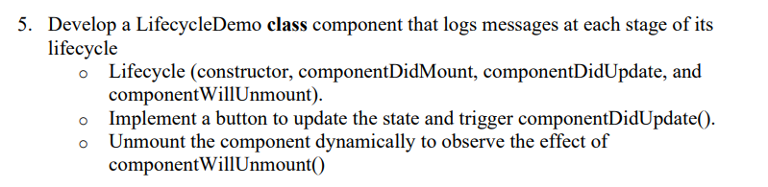

Code:

**App.jsx**

import React, { useState } from "react";

import LifecycleDemo from "./Components/LifecycleDemo";

function App() {

  const [showComponent, setShowComponent] = useState(true);

  return (

    <div>

      <h1>React Lifecycle Demo</h1>

      <button onClick={() => setShowComponent(!showComponent)}>

        {showComponent ? "Unmount Component" : "Mount Component"}

      </button>

      {showComponent && <LifecycleDemo />}

    </div>

  );

}

export default App;

**LifecycleDemo.jsx**

import React, { Component } from "react";

class LifecycleDemo extends Component {

  constructor(props) {

    super(props);

    this.state = { count: 0 };

    console.log("Constructor: Component is initialized");

  }

  componentDidMount() {

    console.log("componentDidMount: Component is mounted");

  }

  componentDidUpdate(prevProps, prevState) {

    console.log("componentDidUpdate: State updated", prevState, "->", this.state);

  }

  componentWillUnmount() {

    console.log("componentWillUnmount: Component is about to be unmounted");

  }

  incrementCount = () => {

    this.setState((prevState) => ({ count: prevState.count + 1 }));

  };

  render() {

    return (

      <div>

        <h2>Lifecycle Demo</h2>

        <p>Count: {this.state.count}</p>

        <button onClick={this.incrementCount}>Increment Count</button>

      </div>

    );

  }

}

export default LifecycleDemo;

Output:

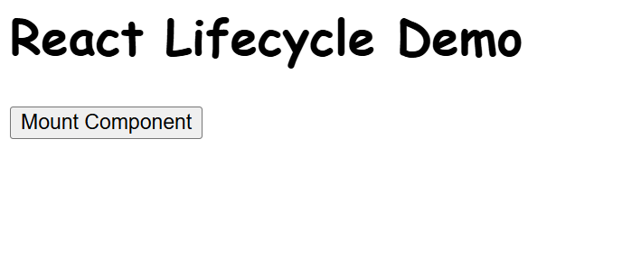

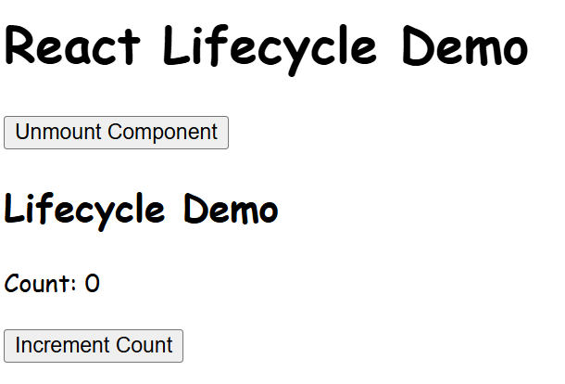

Question 6:

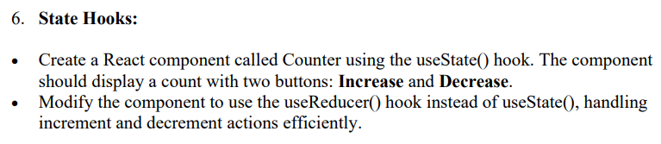

Code:

**App.jsx**

import React from "react";

import Counter1 from "./Components/Counter1";

import Counter2 from "./Components/Counter2";

function App() {

  return (

    <div>

      <h1>React Counter Demo</h1>

      <h2>Using useState</h2>

      <Counter1 />

      <h2>Using useReducer</h2>

      <Counter2 />

    </div>

  );

}

export default App;

**Counter1.jsx**

import React, { useState } from "react";

function Counter1() {

  const [count, setCount] = useState(0);

  return (

    <div>

      <p>Count: {count}</p>

      <button onClick={() => setCount(count + 1)}><strong>Increase</strong></button>

      <button onClick={() => setCount(count - 1)}><strong>Decrease</strong></button>

    </div>

  );

}

export default Counter1;

**Counter2.jsx**

import React, { useReducer } from "react";

const reducer = (state, action) => {

  switch (action.type) {

    case "INCREMENT":

      return { count: state.count + 1 };

    case "DECREMENT":

      return { count: state.count - 1 };

    default:

      return state;

  }

};

function Counter2() {

  const [state, dispatch] = useReducer(reducer, { count: 0 });

  return (

    <div>

      <p>Count: {state.count}</p>

      <button onClick={() => dispatch({ type: "INCREMENT" })}><strong>Increase</strong></button>

      <button onClick={() => dispatch({ type: "DECREMENT" })}><strong>Decrease</strong></button>

    </div>

  );

}

export default Counter2;

Output:

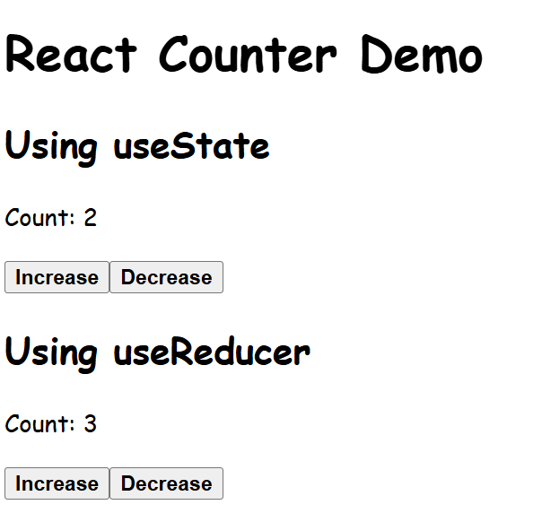

Question 7:

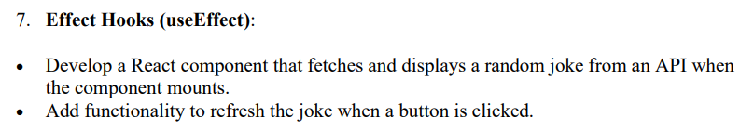

Code:

**App.jsx**

import React from "react";

import Joke from "./Components/Joke";

function App() {

  return (

    <div>

      <h1>Random Joke Generator</h1>

      <Joke />

    </div>

  );

}

export default App;

**Joke.jsx**

import React, { useState, useEffect } from "react";

function Joke() {

  const [joke, setJoke] = useState("");

  const fetchJoke = async () => {

    try {

      const response = await fetch("https://api.chucknorris.io/jokes/random");

      const data = await response.json();

      setJoke(data.value);

    } catch (error) {

      console.error("Error fetching joke:", error);

    }

  };

  useEffect(() => {

    fetchJoke();

  }, []);

  return (

    <div>

      <p>{joke || "Loading joke..."}</p>

      <button onClick={fetchJoke}>Get New Joke</button>

    </div>

  );

}

export default Joke;

Output:

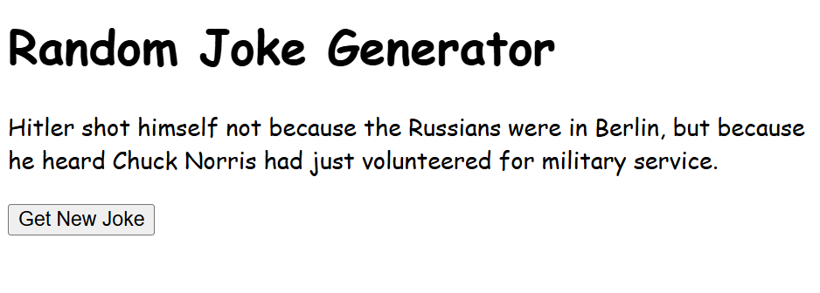

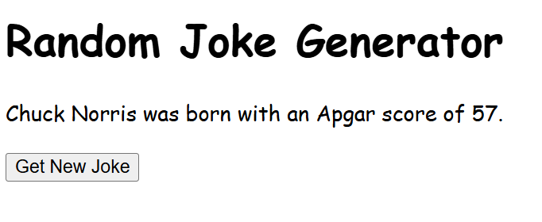

Question 8:

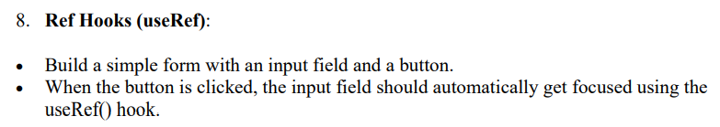

Code:

**App.jsx**

import React from "react";

import Form from "./Components/Form";

function App() {

  return (

    <div>

      <h1>Focus Input Field Demo</h1>

      <Form />

    </div>

  );

}

export default App;

**Form.jsx**

import React, { useRef } from "react";

function Form() {

  const inputRef = useRef(null);

  const handleFocus = () => {

    if (inputRef.current) {

      inputRef.current.focus();

    }

  };

  return (

    <div>

      <input ref={inputRef} type="text" placeholder="Type here..." />

      <button onClick={handleFocus}>Focus Input</button>

    </div>

  );

}

export default Form;

Output:

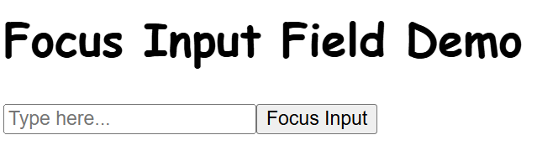

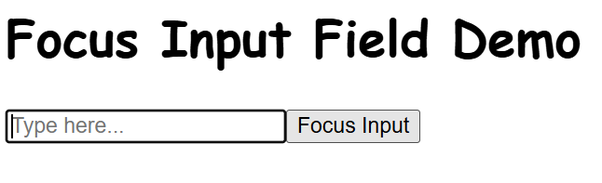

Question 9:

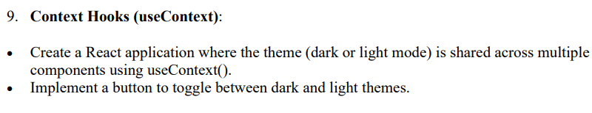

Code:

**App.jsx**

import React, { createContext, useState } from "react";

import Mode from './Components/Mode.jsx'

export const ThemeContext = createContext();

function App() {

  const [theme, setTheme] = useState("light");

  const toggleTheme = () => {

    setTheme((prevTheme) => (prevTheme === "light" ? "dark" : "light"));

  };

  return (

    <ThemeContext.Provider value={{ theme, toggleTheme }}>

      <div className={theme === "light" ? "light-theme" : "dark-theme"}>

        <h1>Theme Toggle Using useContext</h1>

        <Mode />

      </div>

    </ThemeContext.Provider>

  );

}

export default App;

**Mode.jsx**

import React, { useContext } from "react";

import { ThemeContext } from "../App";

function Mode() {

  const { theme, toggleTheme } = useContext(ThemeContext);

  return (

    <div>

      <p>Current Theme: {theme}</p>

      <button onClick={toggleTheme}>

        Switch to {theme === "light" ? "Dark" : "Light"} Mode

      </button>

    </div>

  );

}

export default Mode;

Output:

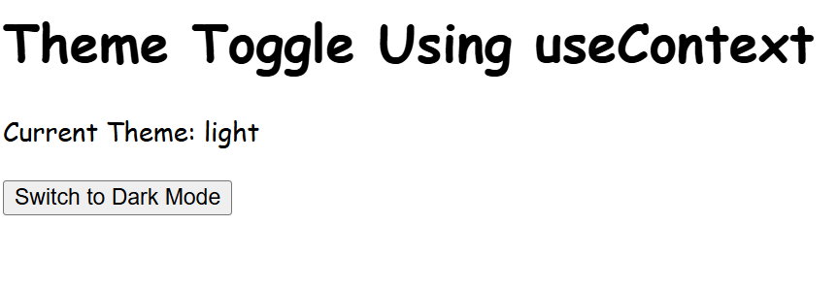

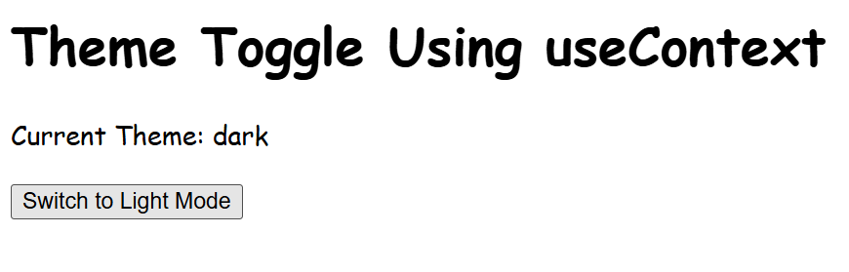

Question 10,11:

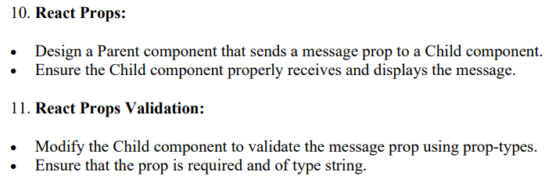

Code:

**App.jsx**

import React from "react";

import ChildComponent from "./Components/ChildComponent";

function App() {

  return (

    <div>

      <h1>React Props & Prop Validation</h1>

      <ChildComponent message="Hello from Parent Component!" />

    </div>

  );

}

export default App;

**ChildComponent.jsx**

import React from "react";

import PropTypes from "prop-types";

function ChildComponent({ message }) {

  return (

    <div>

      <p>Message from Parent: {message}</p>

    </div>

  );

}

// Prop validation using prop-types

ChildComponent.propTypes = {

  message: PropTypes.string.isRequired, // Ensures `message` is a required string

};

export default ChildComponent;

Output:

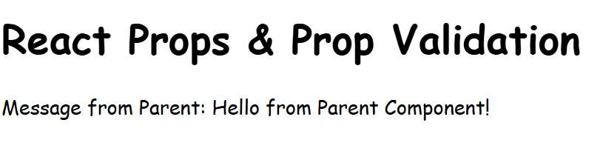

Question 12:



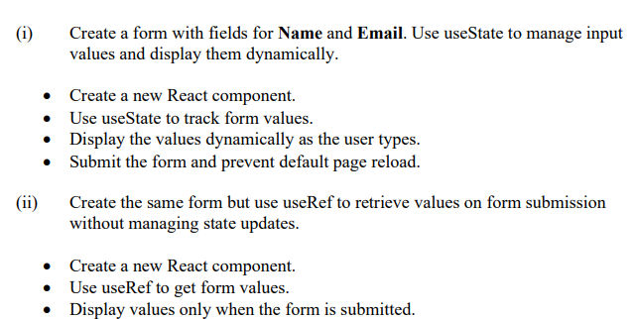

Code:

**App.jsx**

import React from "react";

import Form1 from "./Components/Form1";

import Form2 from "./Components/Form2";

function App() {

  return (

    <div>

      <h1>Form Handling with useState and useRef</h1>

      <h2>Using useState:</h2>

      <Form1 />

      <h2>Using useRef:</h2>

      <Form2 />

    </div>

  );

}

export default App;

**Form1.jsx**

import React, { useState } from "react";

function Form1() {

  const [formData, setFormData] = useState({ name: "", email: "" });

  const handleChange = (e) => {

    setFormData({ ...formData, [e.target.name]: e.target.value });

  };

  const handleSubmit = (e) => {

    e.preventDefault();

    alert(`Submitted Data: Name - ${formData.name}, Email - ${formData.email}`);

  };

  return (

    <form onSubmit={handleSubmit}>

      <label>

        Name:

        <input

          type="text"

          name="name"

          value={formData.name}

          onChange={handleChange}

        />

      </label>

      <br />

      <label>

        Email:

        <input

          type="email"

          name="email"

          value={formData.email}

          onChange={handleChange}

        />

      </label>

      <br />

      <button type="submit">Submit</button>

      <h3>Live Preview</h3>

      <p>Name: {formData.name}</p>

      <p>Email: {formData.email}</p>

    </form>

  );

}

export default Form1;

**Form2.jsx**

import React, { useRef, useState } from "react";

function Form2() {

  const nameRef = useRef();

  const emailRef = useRef();

  const [submittedData, setSubmittedData] = useState(null);

  const handleSubmit = (e) => {

    e.preventDefault();

    setSubmittedData({

      name: nameRef.current.value,

      email: emailRef.current.value,

    });

  };

  return (

    <form onSubmit={handleSubmit}>

      <label>

        Name:

        <input type="text" ref={nameRef} />

      </label>

      <br />

      <label>

        Email:

        <input type="email" ref={emailRef} />

      </label>

      <br />

      <button type="submit">Submit</button>

      {submittedData && (

        <div>

          <h3>Submitted Data</h3>

          <p>Name: {submittedData.name}</p>

          <p>Email: {submittedData.email}</p>

        </div>

      )}

    </form>

  );

}

export default Form2;

Output:

